**BUS RESERVATION SYSTEM**

# BUS RESERVATION SYSTEM

# EXPERIMENT-8

**To draw the behavioural view diagram: Sequence diagram, Collaboration diagram.**

**Sequence Diagram**

Scenario: Locating a Bus

1. User Requests Bus reservation

- The user requests the current location of a bus.

2. System Determines Bus Availability

- The system checks the availability of buses and their current routes.

3. System Retrieves Bus Location

- The system identifies the bus closest to the user's requested location.

4. System Displays Bus Location

- The system displays the bus location to the user.

This adapted scenario for a bus reservation system focuses on how a user interacts with the system to obtain real-time information about bus locations. Each step emphasizes the sequence of actions and interactions between the user and the system.

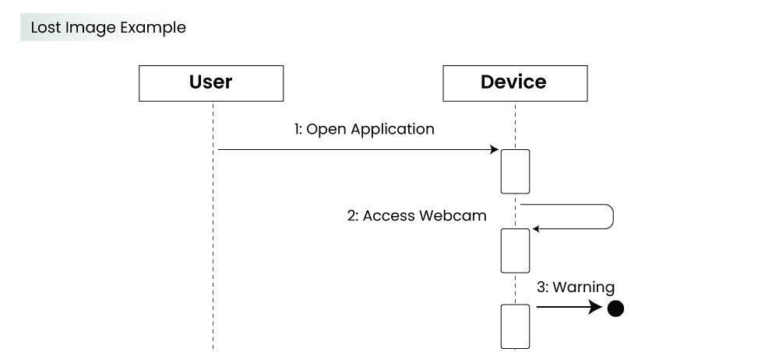

# RESERVATION MANAGEMET SYSTEM

**Collaboration Diagram: Bus reservation system**

Certainly! Let's adapt the collaboration diagram for a bus reservation system :

**Collaboration Diagram: Bus reservation system**

In a bus reservation system , the interactions between objects can be illustrated as follows:

**- User**

- Requests bus location

- **Bus reservation system**

- BusManager

- Manages buses and their locations

- Bus

- Represents an individual bus

- Location

- Represents the current location of the bus

Here’s how the interactions can be represented:

1. User Requests Bus Location

- User sends a request for bus location.

- Bus reservation system (BusManager) receives the request.

2. Bus reservation system Determines Bus Availability

- Bus reservation system checks the availability of buses and their current locations.

3. Bus reservation system Retrieves Bus Location

- Bus reservation system identifies the bus closest to the user's requested location.

- The system communicates with the **Bus** object to retrieve its current **Location**.

4. Bus reservation system Provides Bus Location to User

- Bus reservation system sends the bus location information back to the User.

In this collaboration diagram:

- User initiates the request for bus location.

- Bus reservation system (represented here as the **BusManager**) coordinates the interactions between different buses (**Bus** objects) and their respective locations (**Location** objects).

- The diagram emphasizes how objects (User, Bus, Location) interact and collaborate to fulfill the user's request for bus location information.

